Compared to 2019, there was a slight increase in female owned businesses (21.9% vs 21.7). The percentage of male owned businesses did not change and remained the same at 64%.

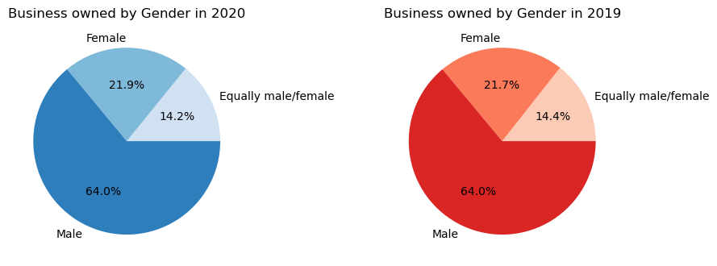

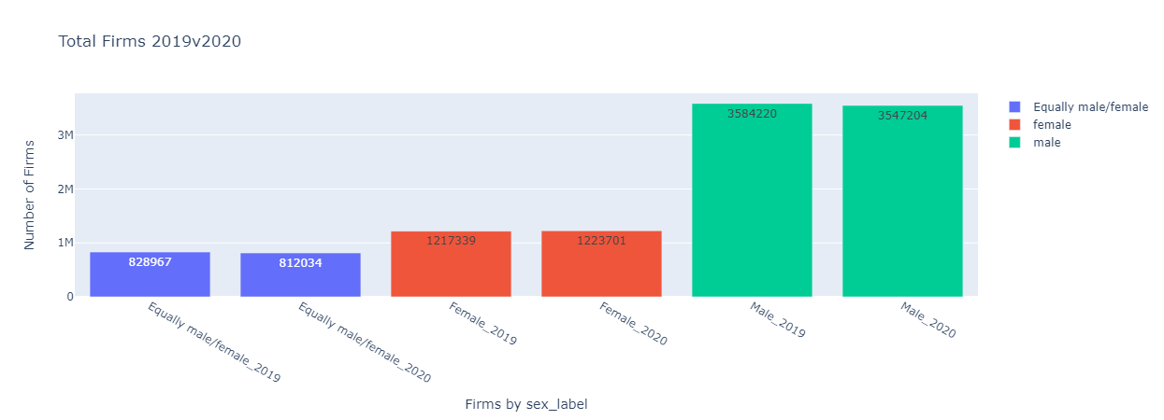

In terms of payroll, female-owned business had a slight increase in total payroll while male-owned business has dropped.

By state, Hawaii and Wyoming had the greatest percentage drop in total annual payroll (11.48% and 11.25% respectively) while Delaware and Utah had the highest percentage increase (9.74% and 7.45% respectively).

